**Recursive Relationships**

In the examples above, a relationship has always been between occurrences in two different entities. However, it is possible for the same entity to participate in the relationship. This is termed a **recursive relationship**.

Let us take the example of an employee who is also a manager. But a manager is also an employee, whose details will be held in the employee entity. To implement this a foreign key of the employee's manager number would be held in each employee record.

**Employee entity**

**Employee no**

Employee surname

Employee forename

Employee DOB

Employee NI number

Manager no * (this is the employee no of the employee's manager)

Graphically, this can be shown as:

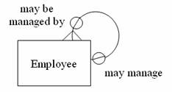

This is commonly know as a 'pig's ear'.

Another, more complicated example (don't worry, you will not be assessed on this) is showing the relationship between a person and their parents. This can be represented graphically by:

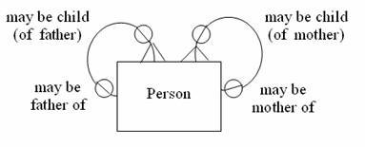

Basically, a recursive relationship is one where an entity is related to a similar entity. For instance, the entity might be PERSON. An attribute of the entity might be MOTHER, which is a PERSON itself. A recursive relationship has been defined because one row in the PERSON table refers to another row in the same PERSON table.